**Go-phish Setup😎(in kalilinux):**

Step1: sudo apt update && sudo apt upgrade -y

Description: This command updates the system package list and then upgrades all your software to the latest version without asking questions.

Step2: wgethttps://github.com/gophish/gophish/releases/download/v0.12.1/gophish-v0.12.1-linux-64bit.zip

Description: This command downloads the GoPhish software package (zip file) from GitHub onto your Kali Linux system

Step3:

unzip gophish-v0.12.1-linux-64bit.zip

cd gophish-v0.12.1-linux-64bit

Description: First command **extracts the GoPhish files**, and the second one **takes you inside that folder** so you can run the program.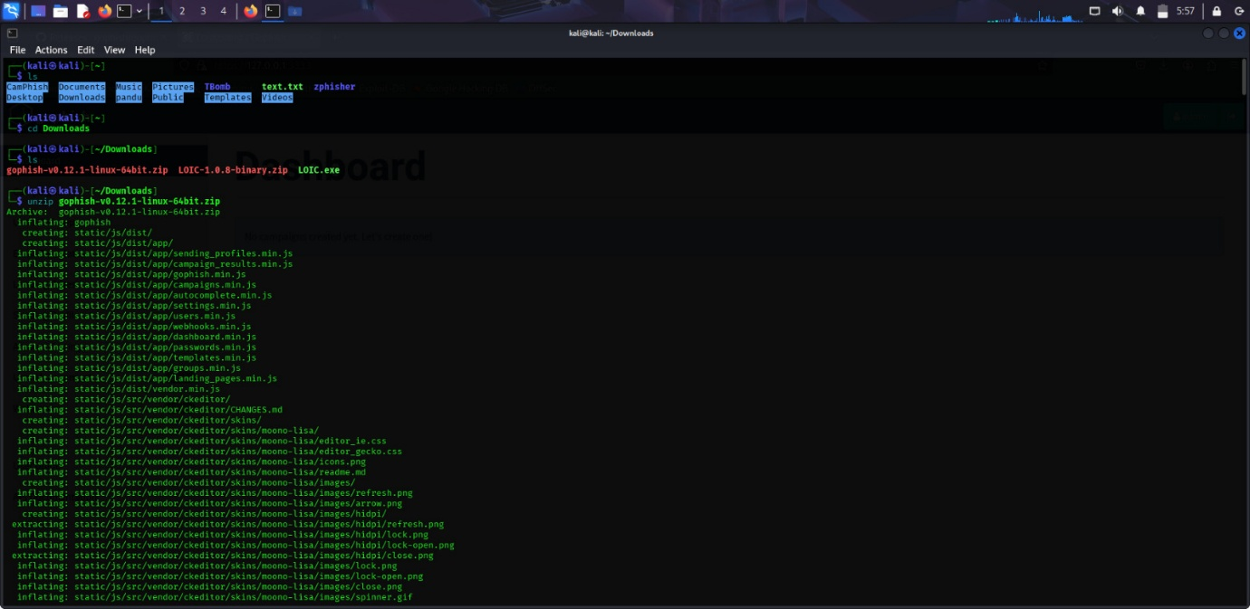

Step4: chmod +x gophish

Description: giving the permission to run

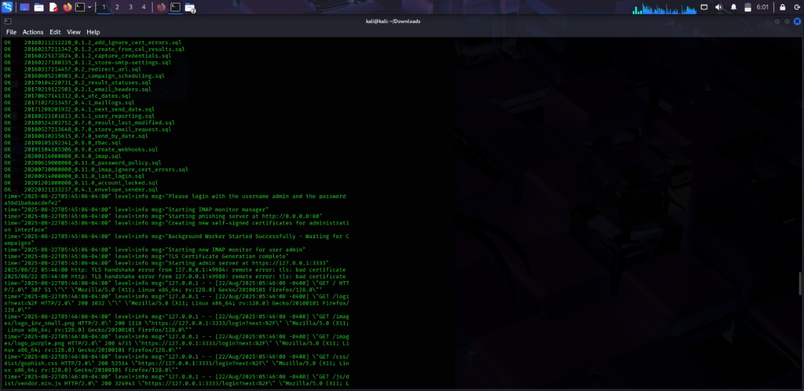

Step4: ./gophish

Description: start the gophish tool it will give the web address like <http://127.0.0.1:3333>

When we click the address we will go to the admin login page of the go-phish.the user-name and password will be displayed on the terminal of the kali linux

